31.10: a) 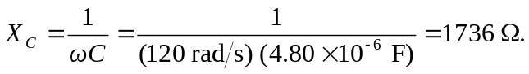
b) To find the voltage across the resistor we need to know the current, which can be found from the capacitor (remembering that it is out of phase by 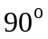 from the capacitor’s voltage).
